2018 Panda Pride “FUN”d Drive: October 1 – October 27
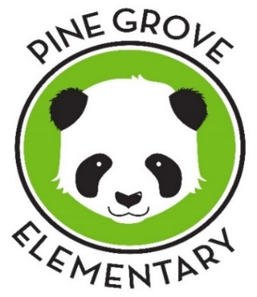

Be a part of the FUN & support our school!!

What do YOU need to know??
Dear parents and PGE families:
- This is the biggest fundraiser of the year! The objective is to raise money for the PTA to provide extra activities for our kids and school.
- When? October 1 - October 27. Money & sponsors will be collected each day - send the money in asap!
- Collect support money and at the end, to celebrate our Panda Pride FUNd Drive success, students will participate in a Healthy Initiative Fun Walk during their specials time, sponsored by the PTA.
- Our goal is to raise $14,000! Each class will be a team with a goal to raise at least $500. Classes that raise the minimum of $500 will win a popcorn & movie party OR a sidewalk chalk & bubble party. Classes that raise $1000+ will win both! Plus: The class that raises the most money will receive a $100 Teacher Supplement for the classroom.
** Students who raise at least $60 through donations or business sponsors
will receive an awesome free PGE Panda Pride t-shirt or magnet**

For 4 weeks, each week there will be a “FUN-raising” activity that students can participate in:
Oct. 1-5 – Spare Change Challenge – Collect spare change and bring it in to your class bucket. The class with the heaviest bucket of change will win a party! (Pro tip: dollar, half dollar, and quarter coins weigh the most!)
Oct. 8-12 – Animals abound! Donate $1 to bring a stuffed animal to sit on your desk on Friday.
Oct. 15-18 – Purple Pen! Donate $1 to purchase a purple pen and write with a purple pen all day on Thursday.
Oct. 22-27 – I “moustache” you to vote … Donate $1 to purchase a moustache pencil and VOTE for which teacher gets to wear a fake moustache on Friday! ($1 for a pencil and 1 vote, all extra votes $1 each)

100% of the donations raised will enable the PTA to provide funding for:
- Reading & writing experience incentives:
Summer Learning Celebration, Panda Power Reading Program, Young Author Celebration
- Ballroom dancing for 5th graders
- Afterschool clubs: Green School club, Art club, Recorder club, iTime, 24 club, and more!
- Homework planner packets
- Awesome assemblies!
- School dances
- and much, much more!!

We need your help!! Our fundraiser won’t be a success without your support.
- Students can use the pledge sheet and letter template to ask friends and family for donations.
- There are sponsorship opportunities for businesses – please use the attached sponsorship forms to ask a business to sponsor us! Sponsorships secured by students will go toward their class goal.
Thank you for your help!

All donations are tax deductible! Donations can be made by cash, check, or by PayPal on our website: www.pinegrovepta.weebly.com. Additional copies of all forms will be posted on the website.
Questions? Contact Karin Wohlgemuth: karin@allfleetsolutions.com, or call/text: 410-967-5116.

Pine Grove Elementary School

Panda Pride “FUN”d Drive 2018!
Donation Form
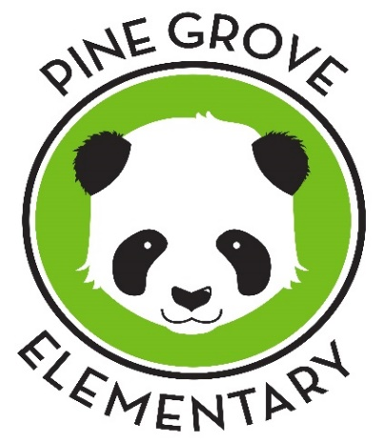
1. Hi, I am in ______ grade at Pine Grove Elementary School.
2. We are collecting donations to raise money for our PTA to do extra activities for the students at our school.
3. I hope to raise $______ to reach my class goal of $____ to win a _____________.
4. Will you please help support me and our school so we can do extra fun activities?!

Student Name: _________________________________________________________
Teacher: ________________________________________________________
Grade: _____________

Supporter Name | Phone Number | $ Donated | $ Collected
Ex. John Doe | 410-555-1212 | $20 | $20
1.

2.

3.

4.

5.

6.

7.
8.
9.
10.

11.

12.

 |  |  | Total:

Donations can be made by cash, check payable to PGE PTA,
or online via PayPal (www.pinegrovepta.weebly.com)
Please return all donations and this sheet before October 31, 2018.

STUDENTS: Did you raise $60 or more?! GREAT JOB!! For your FREE t-shirt please circle your size:
YOUTH or ADULT -Small- -Medium- -Large- OR -PGE Panda Refrigerator/Locker Magnet-

Dear ______________________ ,
My school is holding a Panda Pride “FUN”d Drive this month to raise money for our PTA to do school activities,
at the end I will be participating in a Healthy Initiative Fun Walk to celebrate our success, sponsored by the PTA!

- Will you please support me in my goal to raise money, so we can learn more through extra fun activities
and do things like the Healthy Initiative Fun Walk?

Our PTA does a lot of cool things for our school like __________________________________________,
_____________________________________________, and ___________________________________.
My class is trying to raise $____________ so we can win a _____________________________________.
Thank you for your generous support for me and my school!
Sincerely,
________________________
*Donations can be made by cash, checks (payable to PGE PTA), or PayPal on www.pinegrovepta.weebly.com
*All donations are tax-deductible *

--------------------------------------------------------------------------------------------------------------------------------------------------------------

Please complete the form below and send to school with your donation.
Or mail to: Pine Grove Elementary School PTA -2701 Summit Avenue-Baltimore, MD 21234

___________________________________________________________________________
Panda Pride FUNd Drive 2018
Student’s Name:____________________________________________________________________
Grade:______________ Teacher:______________________________________________________
Donor’s Name:___________________________________ Donation amount:___________________

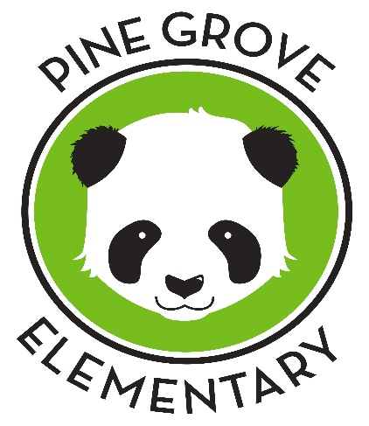
PINE GROVE ELEMENTARY SCHOOL PTA
2701 Summit Avenue - Parkville, Maryland 21234

Panda Pride
Business Sponsorship

JOIN US: in PANDA PRIDE Sponsorship!

Can YOU sponsor PGE?? YES, YOU CAN!! … and it’s great visibility for your business!

Over 250 families will see your support of our school & community

In October, the students of Pine Grove Elementary are showing their PANDA POWER
by raising money to support our school. Our goal is $14,000!

100% of your generous donation will enable the PTA to provide funding for:

- extra reading & writing experiences and incentives
- Ballroom dancing for 5th graders
- afterschool clubs
- homework planners
- Awesome assemblies!
- special classroom resources
- school dances
- and much, much more!

* fun activity weeks * class fundraising competitions * rewards for students who raise $60+ *

ALL students will be celebrating their success at a healthy initiative walk/run sponsored by the PTA!

Please give generously and encourage students in their Panda Pride and hard work by sponsoring us. This is the PTA’s primary fundraiser – encourage students and be a part of their success!!

Without the PTA, the students will not have access to these things. We are asking area businesses to invest in our students and help us reach our goal.

We need YOUR help to make this a success!
(Look on the reverse side of this sheet for the Sponsorship form)

Please consider making a tax-deductible donation today!

BUSINESS SPONSORSHIP LEVELS
*We are a registered 501 (c)(3), all donations are Tax-Deductible*

_____ $1,500 Giant Panda Sponsor
- Track Sign advertising your business at the healthy initiative celebration
- Your business’ website link on the PGE PTA website
- An Ad in the 2018/19 PGE Yearbook
- Your business’ logo on the PGE PTA website
- Panda Pride plaque to hang in your business
- Promotion on Facebook and e-blast newsletter to PGE families

____ $500 Panda Pride Sponsor
- Track Sign advertising your business at the healthy initiative celebration
- Acknowledgement in 2018/19 PGE Yearbook
- Your business’ logo on the PGE PTA website
- Panda Pride plaque to hang in your business
- Promotion on Facebook and e-blast newsletter to PGE families
____ $200 Bamboo Sponsor
- Acknowledgement in 2018/19 PGE Yearbook
- Your business’ logo on the PGE PTA website
- Certificate to hang in your business
- Promotion on Facebook and e-blast newsletter to PGE families

____ $50 Friend of PGE Sponsor
- Acknowledgement in 2018/19 PGE Yearbook and website
- Certificate to hang in your business
- Promotion on Facebook and e-blast newsletter to PGE families

____ $Other – Create your own level of any amount!
- Promotion on Facebook and e-blast newsletter to PGE families
- Tax-deductible receipt for your business
Company Name:
Contact Name:
Address:
Email: Phone:
Website Address:
Student’s Name and Teacher:

If you’d like to be a sponsor – return the completed form and payment to your student’s homeroom teacher or mail to: Pine Grove Elementary School PTA, 2701 Summit Ave, Baltimore, MD 21234

Make checks payable to ‘PGE PTA’ or via credit card using Pay Pal at pinegrovepta.weebly.com
Questions? Contact Karin Wohlgemuth at karin@allfleetsolutions.com or 410-967-5116.

